2026 Sir Henry Brooke Award recognises Ms Ruth López
On Tuesday, 10 March 2026, the Alliance for Lawyers at Risk recognised Ruth Eleonora López as the recipient of the 2026 Sir Henry Brooke Award.
Ms López is an outstanding human rights lawyer and one of the most prominent advocates for the rule of law in El Salvador. Over the course of her career, she has courageously exposed corruption, served as a legal advisor to public institutions, represented judges and magistrates unlawfully dismissed by the government, and challenged the mass violation of human rights that has taken place under El Salvador’s “state of exception” declared in March 2022, which has remained in place ever since. Most recently, she led the Anti-Corruption and Justice Unit at the NGO Cristosal and has for many years been at the forefront of efforts to expose corruption, defend access to justice for migrants, and document the erosion of democratic institutions in El Salvador.
Regrettably, Ms López was arrested in May 2025 and remains in custody in El Salvador, where she has been denied meaningful access to legal representation.
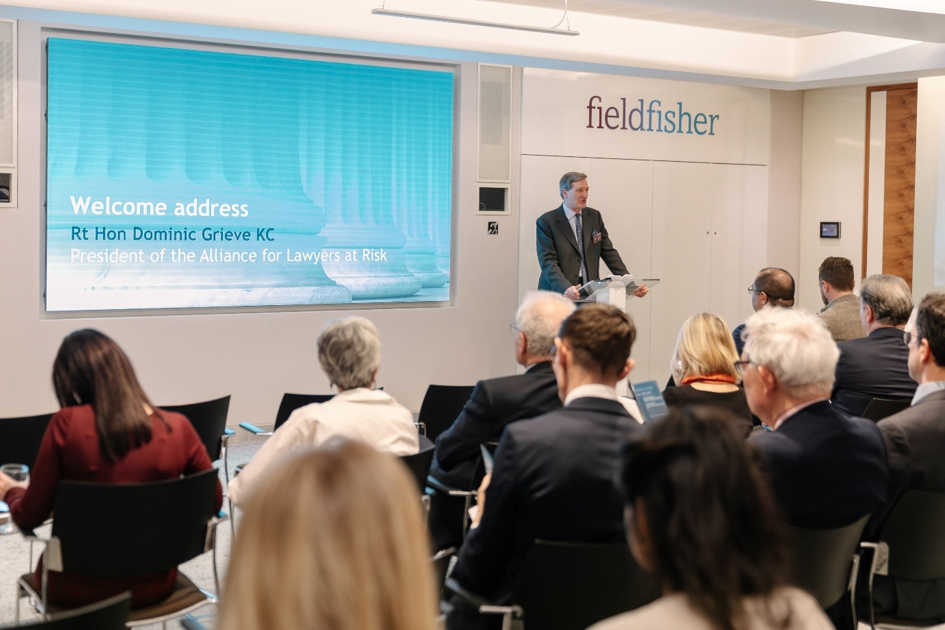
Mr Dominic Grieve KC, the President of the Alliance, welcomes guests to the 2026 Sir Henry Brooke Award ceremony
The award ceremony was held at the offices of our co-sponsor for the 2026 Sir Henry Brooke Award, City law firm Fieldfisher. It was attended by more than 100 guests, including some of the UK’s most senior judges and distinguished representatives from the British and international legal communities, who came together in London to recognise the extraordinary work of Ms López.
The ceremony was hosted by the President of the Alliance, Mr Dominic Grieve KC who had the privilege of welcoming Sir Geoffrey Vos, the Master of the Rolls, as the keynote speaker.

The Master of the Rolls’s speech reflected on the meaning of the “rule of law” and how the modern public – particularly younger generations – often lacks a clear understanding of what lawyers mean when they say it. Noting the historic reality that equal access to justice once served only a privileged few, he highlighted that “the citizens and businesses of our country [now] expect to see a system where justice is available equally to the least privileged and the most vulnerable in our society as it is to the most wealthy and the most privileged,” and argued that this change makes the rule of law “even more important in 2026 than ever before.”
The Master of the Rolls urged the legal community to “explain that, as proponents of the rule of law, we are proponents of the clear and accessible predictability of the legal system, that we support open justice and access to fair justice for all, that we are seeking to protect the fundamental rights of all, and we support those states that exercise proportionate and accountable power over their citizens in good faith, and – more than ever in the modern world – those states that comply with their obligations under national and international law.” Ruth López, he said, “epitomises the qualities that I have mentioned”.
The full speech delivered by the Master of the Rolls is available to read via the following link: https://www.judiciary.uk/speech-by-the-master-of-the-rolls/
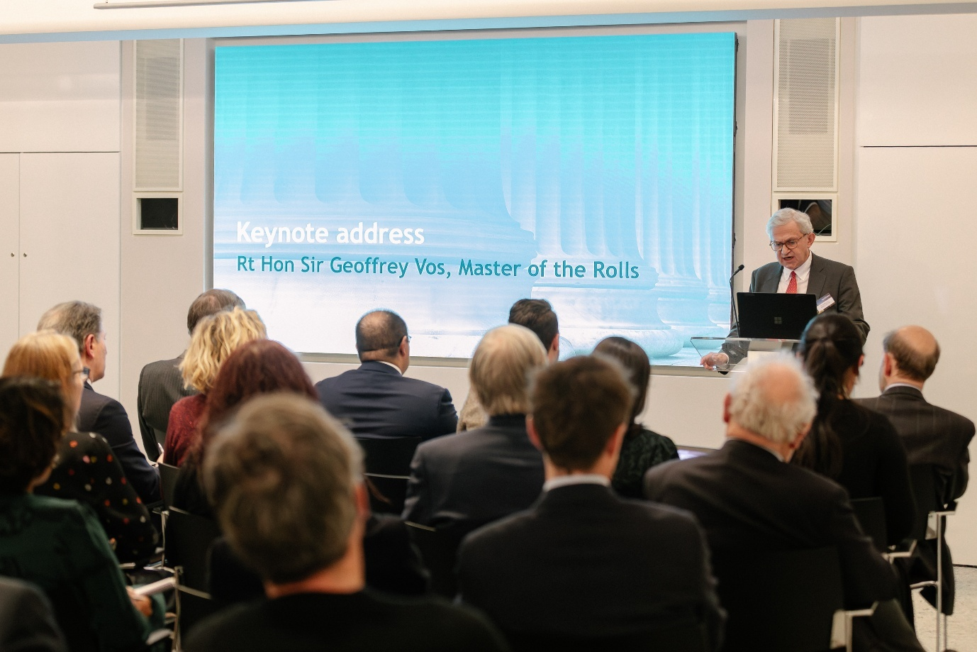
The keynote speech was delivered by Sir Geoffrey Vos, the Master of the Rolls
Following his keynote speech, the Master of the Rolls presented the 2026 Sir Henry Brooke Award to Mr Louis Benavides, Ms López’s husband, who had travelled to London from San Salvador to accept the award on her behalf.
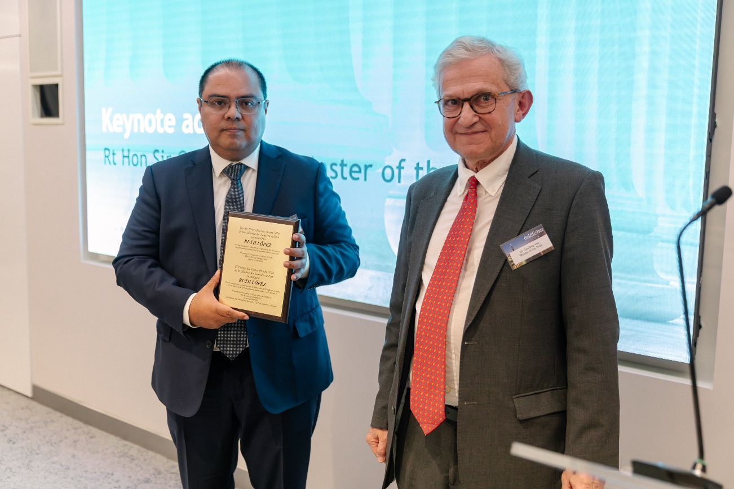
The Master of the Rolls presents Mr Louis Benavides with the 2026 Sir Henry Brooke Award, which he receives on behalf of his wife, Ms Ruth López
In his deeply moving acceptance speech, Mr Benavides emphasised the unwavering commitment and remarkable perseverance of Ms López, as well as the profound sacrifices endured by herself and their family. He also highlighted her colleagues in El Salvador and across the globe who fight each day to uphold the rule of law. His words resonated powerfully with all present and earned an overwhelming ovation.
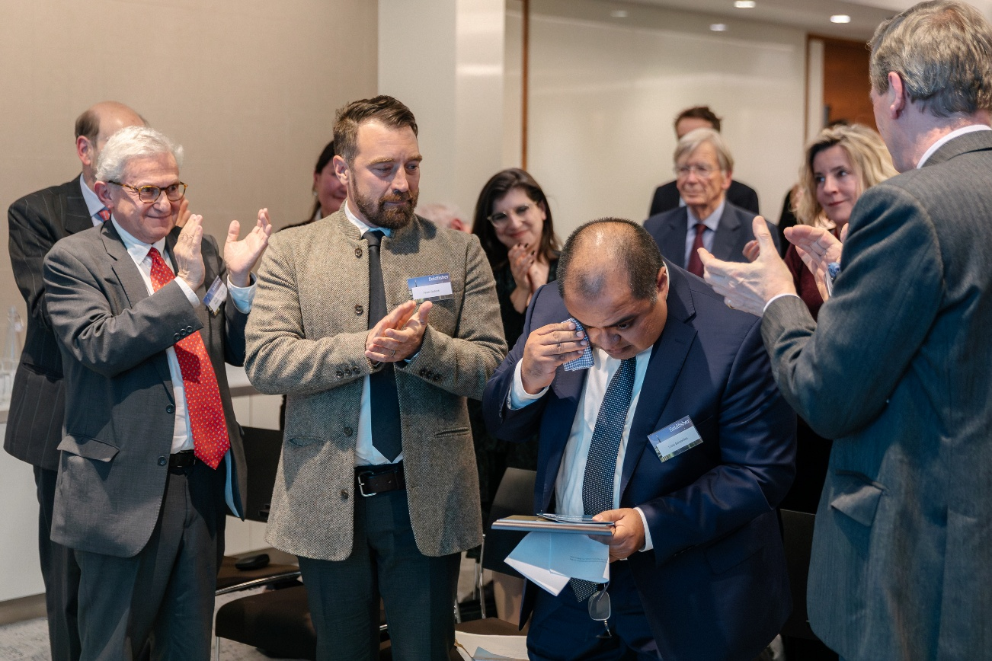
Mr Benavides delivered a powerful acceptance speech at the 2026 Sir Henry Brooke Award ceremony on behalf of his wife, Ruth López
Those present also had the opportunity to hear from Mr Noah Bullock, Executive Director of Cristosal, who reflected on his experiences working alongside Ms López.
Mr Bullock spoke movingly about the persecution endured by Ms López, himself, and their colleagues at Cristosal, as well as the ongoing widespread human rights violations taking place in El Salvador.
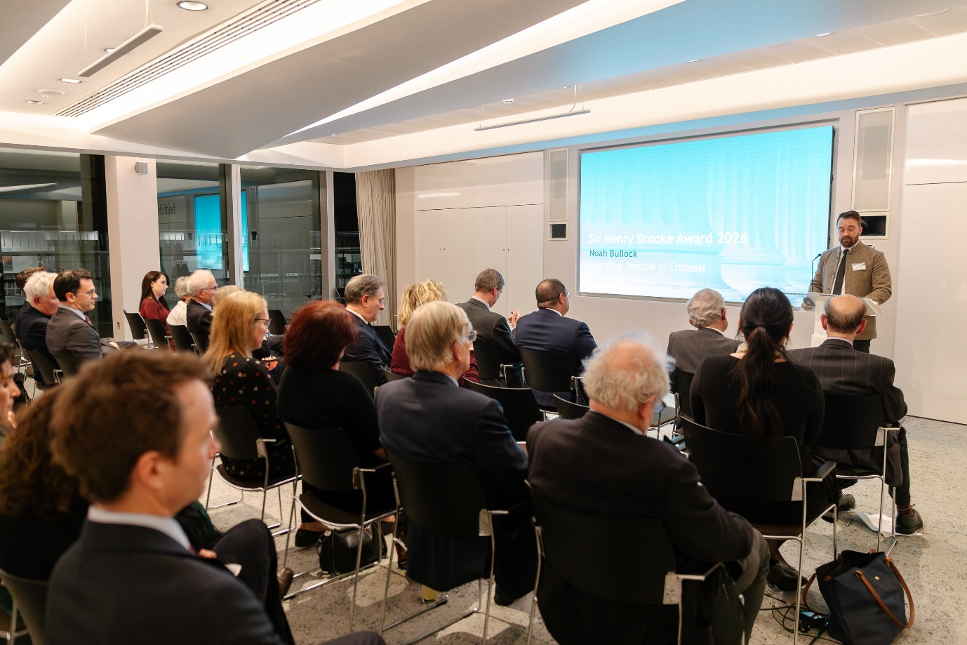
Nominations for the 2026 Sir Henry Brooke Award were assessed by an independent selection panel comprising Professor Christine Chinkin (chair), Lord Dyson, Sir Patrick Elias, Maya Lester KC, and Lizzette Robleto de Howarth.
The 2026 Award: Ms López’s work
The Award recognises Ms López for her longstanding commitment to promoting transparency, accountability, and justice within El Salvador and across the region, at great personal risk and sacrifice.
Over the course of her distinguished career, she has served as a constitutional lawyer, academic, and human rights advocate, navigating challenging conditions marked by political volatility, institutional consolidation, and increasing democratic decline in El Salvador. As Director of the Anti-Corruption and Justice Unit at Cristosal – a regional human rights organisation working across El Salvador, Guatemala, and Honduras – Ms López oversaw significant legal actions to uncover and address corruption within the Salvadoran government. Her investigations have brought to light issues such as unlawful spyware surveillance, political patronage networks, and unconstitutional legislative measures that restrict and undermine public access to information. Under her leadership, Cristosal has expanded its capacity to support victims of state abuse in El Salvador, Guatemala, and Honduras, enhancing protections for human rights throughout the region.
Ms López’s advocacy has received global recognition from many organisations around the world. In 2024, the BBC named her among the 100 most inspiring and influential women in the world, acknowledging the far-reaching impact of her work, and in 2025, she received the American Bar Association’s International Human Rights Award.
Regrettably, Ms López has endured escalating persecution from the Salvadoran authorities for her efforts. On 18 May 2025, she was arrested without prior notice by the National Civil Police, placed in custody, and denied access to both her family and legal counsel. Her imprisonment has been widely condemned by human rights organisations as part of a broader attempt by Salvadoran authorities to intimidate lawyers who challenge government practices.
Ruth López’s selection as the recipient of the 2026 Sir Henry Brooke Award honours not only her personal sacrifices, but also the broader efforts of lawyers worldwide who work to defend and uphold the rule of law in environments of repression.
The Alliance reiterates its thanks to the co-sponsors of the 2026 Sir Henry Brooke Award ceremony, Fieldfisher and Fountain Court Chambers – the very Chambers from which Sir Henry Brooke practised prior to embarking on his judicial career. The ceremony would not have been possible without their generous support, and the Alliance is grateful for their partnership.

